Daniel’s Historical Timeline
The book of Daniel is best understood against one of the most turbulent periods in Old Testament history: the collapse of the Assyrian Empire, the rise and fall of Babylon, the destruction of Jerusalem, the Babylonian exile, and the sudden conquest of Babylon by the Medo-Persian Empire.
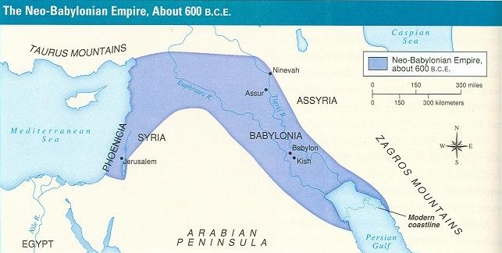
Daniel's recorded life spans roughly 615–536 BC, meaning that he lived through the reigns of several kings and at least three major imperial systems. The political world literally changed around him while he remained a servant of God within foreign governments.

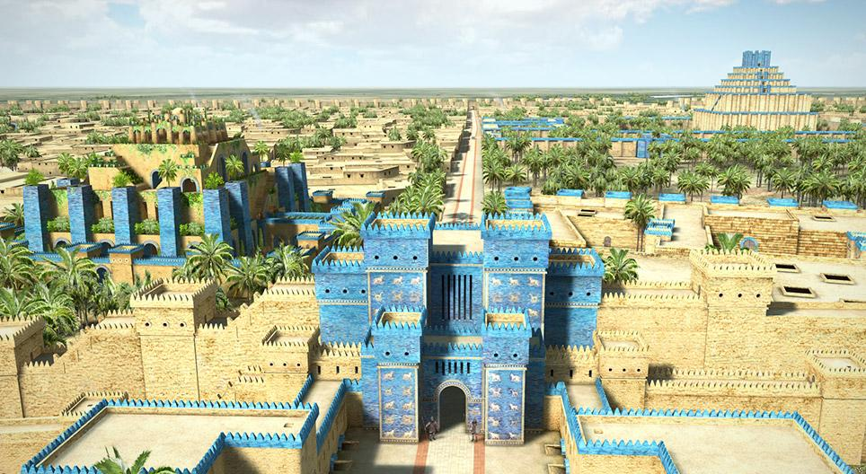
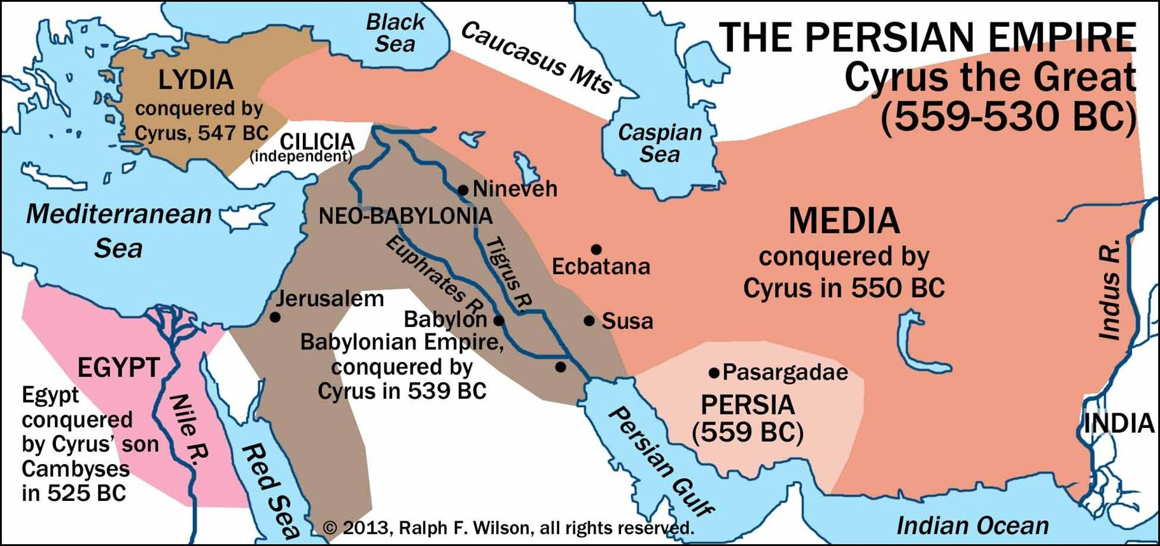

The great powers surrounding Judah

Around Daniel's lifetime, four major political entities are particularly important:
Power | Time | Relationship to Daniel/Judah
Assyria | Before 609 BC | Former dominant empire; rapidly collapsing
Egypt | 609–605 BC | Temporarily controlled Judah
Babylon | 605–539 BC | Conquered Judah and deported Daniel
Medo-Persia | From 539 BC | Conquered Babylon; Daniel continued serving under the new regime
Daniel therefore lived at the intersection of Egyptian, Babylonian, Median, and Persian imperial ambitions.

The world into which Daniel was born

Daniel’s age -- 0 to 6 y.o.
Daniel was probably born around 615 BC, although Scripture does not give his birth date. That means Daniel probably grew up during the reign of King Josiah of Judah (640–609 BC).
This is important because Josiah was one of Judah's great reforming kings. During his reign, the Book of the Law was rediscovered in the Temple, and Josiah attempted to eliminate idolatry and restore covenant worship.
Daniel therefore may have spent his childhood during a remarkable period of spiritual reform but politically, the world around Judah was collapsing.

The collapse of Assyria — 612 BC
Daniel’s age -- 3 y.o.
For much of the eighth and seventh centuries BC, the dominant superpower of the Near East had been the Assyrian Empire.
Assyria had already destroyed the northern kingdom of Israel in approx. 722 BC.
But by Daniel's childhood, Assyria was collapsing. A coalition involving the Babylonians and Medes captured the Assyrian capital of Nineveh in 612 BC.
The remaining Assyrian forces withdrew westward toward Harran and eventually disappeared as a significant imperial power. This created a geopolitical vacuum.

King Josiah conquered by Egypt -- 609 BC

Daniel’s age -- 6 y.o.
He appears to have been a teenager or young man when he was deported to Babylon in 605 BC.
Daniel 1:3–4 describes Daniel and his companions as young Israelites who were physically healthy, intelligent, well educated, and apparently connected with the royal family or nobility.

Two powers now competed to control the region:
Egypt (from the south) and Babylon (from the east)
Judah was caught directly between them.

4. 609 BC — Josiah is killed by Pharaoh Necho II
In 609 BC, Pharaoh Necho II of Egypt marched north through Judah.
King Josiah attempted to stop him at Megiddo.
Josiah was killed. This event appears in 2 Kings 23:29–30 and 2 Chronicles 35:20–24.
Josiah's death was enormously important because Judah lost the king who had led its religious reforms.
Egypt then asserted control over Judah.
Josiah's son Jehoahaz became king but ruled only about three months.
Pharaoh Necho removed him and installed another of Josiah's sons, Eliakim, changing his name to Jehoiakim who ruled from 609–598 BC.

Daniel's world changes forever with the Battle of Carchemish -- 605 BC

Daniel’s age -- 10 y.o.
He appears to have been a teenager or young man when he was deported to Babylon in 605 BC.
Daniel 1:3–4 describes Daniel and his companions as young Israelites who were physically healthy, intelligent, well educated, and apparently connected with the royal family or nobility.

Two powers now competed to control the region:
Egypt (from the south) and Babylon (from the east)
Judah was caught directly between them.
The Babylonian crown prince Nebuchadnezzar confronted Pharaoh Necho's Egyptian army at Carchemish, near the Euphrates River. Babylon won a decisive victory.
The prophet Jeremiah specifically refers to this event in Jeremiah 46:2.
The victory effectively transferred control of Syria-Palest from Egypt to Babylon.
Judah was now trapped under the power of the Neo-Babylonian Empire.
Nebuchadnezzar moved southward and brought Jerusalem under Babylonian authority.
According to Daniel 1:1–6, some of the Temple vessels and a selected group of young Judeans were taken to Babylon.
Among them were:
Daniel — Belteshazzar Hananiah — Shadrach
Mishael — Meshach Azariah — Abednego
This was probably the first Babylonian deportation of Judah, around 605 BC.
Daniel's life changed permanently

6. Daniel is transported from Jerusalem to Babylon
He appears to have been a teenager or young man when he was deported to Babylon in 605 BC.
Daniel 1:3–4 describes Daniel and his companions as young Israelites who were physically healthy, intelligent, well educated, and apparently connected with the royal family or nobility.

Two powers now competed to control the region:
Egypt (from the south) and Babylon (from the east)
Judah was caught directly between them.
The Babylonian crown prince Nebuchadnezzar confronted Pharaoh Necho's Egyptian army at Carchemish, near the Euphrates River. Babylon won a decisive victory.
The prophet Jeremiah specifically refers to this event in Jeremiah 46:2.
The victory effectively transferred control of Syria-Palest from Egypt to Babylon.
Judah was now trapped under the power of the Neo-Babylonian Empire.
Nebuchadnezzar moved southward and brought Jerusalem under Babylonian authority.
According to Daniel 1:1–6, some of the Temple vessels and a selected group of young Judeans were taken to Babylon.
Among them were:
Daniel — Belteshazzar Hananiah — Shadrach
Mishael — Meshach Azariah — Abednego
This was probably the first Babylonian deportation of Judah, around 605 BC.
Daniel's life changed permanently

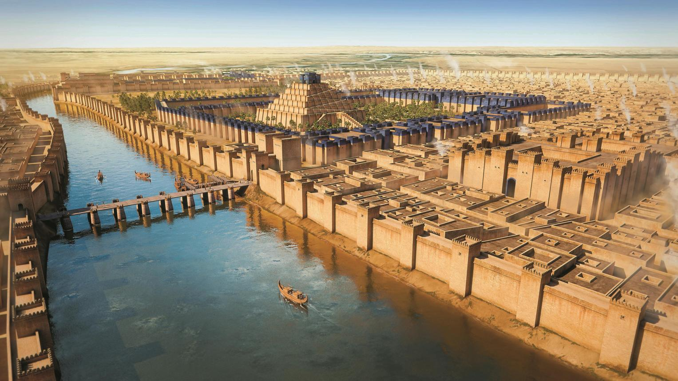
Daniel probably traveled hundreds of miles from Judah to Babylon.
Babylon was not merely another city. It was the capital of perhaps the most
impressive empire Daniel had ever encountered.

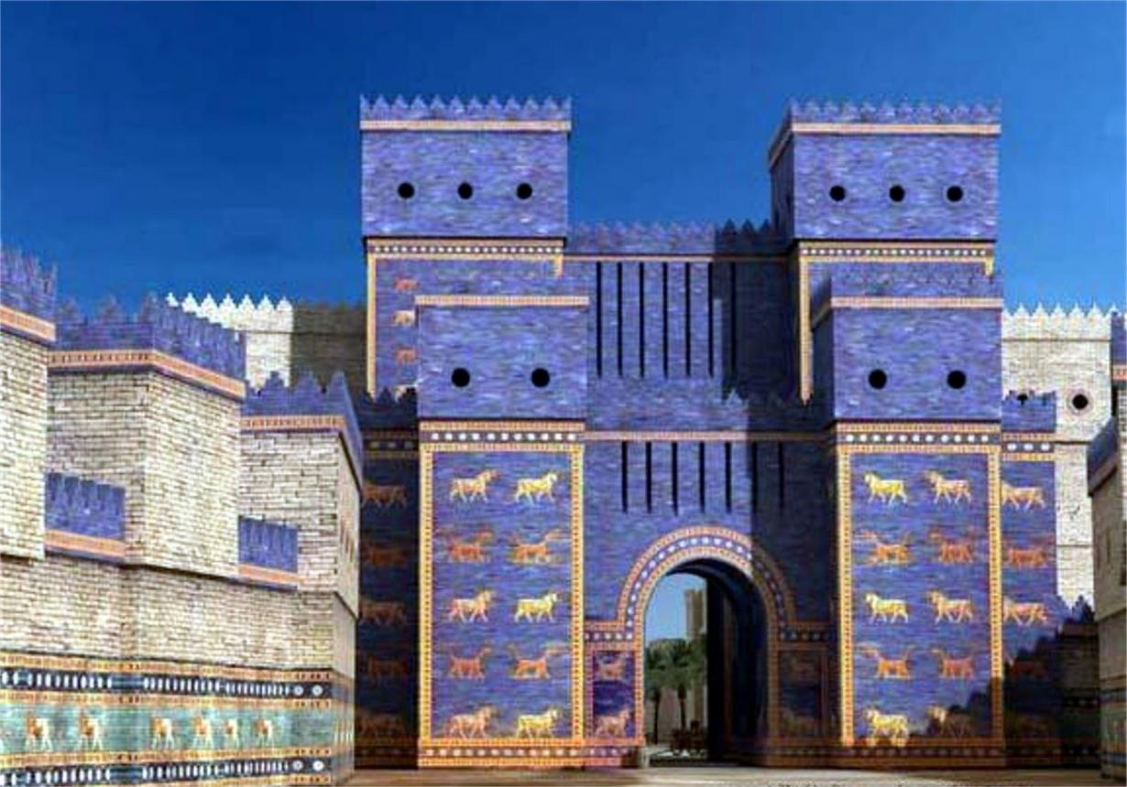
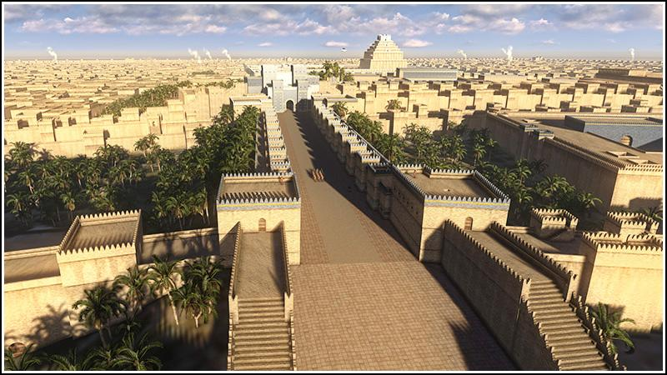

Nebuchadnezzar transformed Babylon into a monumental imperial capital with enormous walls, temples, palaces, gates, and processional avenues.

The famous Ishtar Gate belonged to this Babylonian building program.
Daniel therefore moved from relatively small Jerusalem into the administrative center of a massive pagan empire. Nebuchadnezzar was not simply educating prisoners. He was attempting to absorb elite Judean youths into Babylonian imperial culture.

Babylon attempts to reshape Daniel's identity

Daniel’s age – 10 – 25 y.o.
Daniel 1 describes a deliberate program of cultural assimilation.
Daniel and his friends received Babylonian: education, literature, language, food and even Babylonian names.
Daniel's Hebrew name probably means something like "God is my judge." His Babylonian name was Belteshazzar. The change represented more than convenience. Ancient names often carried theological meaning. The empire was effectively saying ‘You are no longer Judean nobles serving the God of Jerusalem. You are Babylonian officials serving the empire.’
Daniel's remarkable response was selective resistance.
He learned Babylonian language and administration. He served Babylonian kings. He apparently became highly competent within the imperial bureaucracy.
But Daniel 1:8 establishes his fundamental boundary:
"Daniel purposed in his heart that he would not defile himself."
Daniel therefore demonstrates something important throughout the book:
He participated in Babylonian government without allowing Babylon to determine his ultimate identity.

Nebuchadnezzar II — approximately 605–562 BC

Daniel’s age -- 10 – 53 y.o.
Nebuchadnezzar is the dominant political figure in the first half of Daniel. He ruled Babylon for approximately 43 years.
Daniel 2 places Daniel within the king's court when Nebuchadnezzar experiences his famous dream of the enormous statue.
The statue contains:
- head of gold
- chest and arms of silver
- belly and thighs of bronze
- legs of iron
- feet involving iron and clay
Daniel declares: "Thou art this head of gold."
Babylon therefore becomes the starting point for Daniel's prophetic vision of successive kingdoms.

597 BC — the second major deportation

Daniel’s age -- 18 y.o.
Babylonian control of Judah did not eliminate rebellion. Jehoiakim eventually rebelled. After his death, his son Jehoiachin became king. Nebuchadnezzar besieged Jerusalem.
In 597 BC, Jerusalem surrendered.
Jehoiachin, members of the royal family, military leaders, craftsmen, and thousands of Judeans were deported to Babylon. Among these deportees was another famous prophet Ezekiel.
Therefore, for part of their lives, Daniel and Ezekiel were contemporaries living within the Babylonian Empire.
Daniel apparently served within the imperial court while Ezekiel ministered among the Jewish exile community.
Even more interestingly, Ezekiel explicitly mentions Daniel in Ezekiel 14:14, 14:20 and 28:3, though scholars debate the identification of the figure intended there.

586 BC — Jerusalem and the Temple are destroyed

Daniel’s age -- 29 y.o.
Judah rebelled again under King Zedekiah. Nebuchadnezzar responded with another invasion. Jerusalem was besieged.
Finally, in 586 BC - some chronologies use 587 BC—the Babylonians captured Jerusalem.
The city was devastated. The Temple of Solomon was destroyed. The walls were demolished.
Zedekiah attempted to escape but was captured.
His sons were killed before him, after which Zedekiah was blinded and transported to Babylon. The kingdom of Judah effectively ceased to exist as an independent monarchy.
For Daniel, this must have been a staggering event.
- The city of his childhood was destroyed.
- The Temple of his God was destroyed.
- The Davidic monarchy appeared to have ended.
- His people were scattered.
And yet the theological message of Daniel is precisely that God's sovereignty had not ended. That becomes one of the central themes of the entire book.

Jeremiah provides the theological background
Daniel should also be read alongside the prophet Jeremiah. Jeremiah had warned Judah that Babylon would become God's instrument of judgment.
Most importantly, Jeremiah predicted that Babylonian domination would last approximately seventy years.
Daniel explicitly tells us that he was reading Jeremiah.
Daniel realizes that Jeremiah's predicted period of desolation is approaching its completion. That realization leads directly into Daniel's great prayer in Daniel 9.
Thus Daniel wasn't operating independently of previous biblical revelation.
He was studying Jeremiah and interpreting current events through Jeremiah's prophecy.

After Nebuchadnezzar — Babylon becomes unstable

Daniel’s age -- 53 y.o.
Nebuchadnezzar died around 562 BC. His death was followed by considerable political instability.
The sequence is roughly:
Babylonian ruler | Approximate reign
Nebuchadnezzar II |  | 605–562 BC
Amel-Marduk |  | 562–560 BC
Neriglissar |  | 560–556 BC
Labashi-Marduk |  | 556 BC
Nabonidus |  | 556–539 BC
Belshazzar |  | co-regent during Nabonidus's reign

539 BC — the fall of Babylon

Daniel’s age -- 76 y.o.
This is perhaps the greatest geopolitical event Daniel personally witnessed.
The Persian king Cyrus II — Cyrus the Great—was expanding rapidly.
He had already defeated the Median kingdom and built a massive new empire.
In 539 BC, Persian forces moved against Babylon.
Babylon fell remarkably quickly.
Daniel 5 presents the event dramatically through Belshazzar's feast.
The mysterious hand writes on the wall:
MENE, MENE, TEKEL, UPHARSIN.
Daniel interprets the message:
Belshazzar's kingdom has been weighed, judged, and will be given to the Medes and Persians.
Daniel 5:30–31 then announces "In that night was Belshazzar the king of the Chaldeans slain."The Babylonian Empire - the empire that had conquered Daniel's homeland and held him for approximately 66 years—was finished.
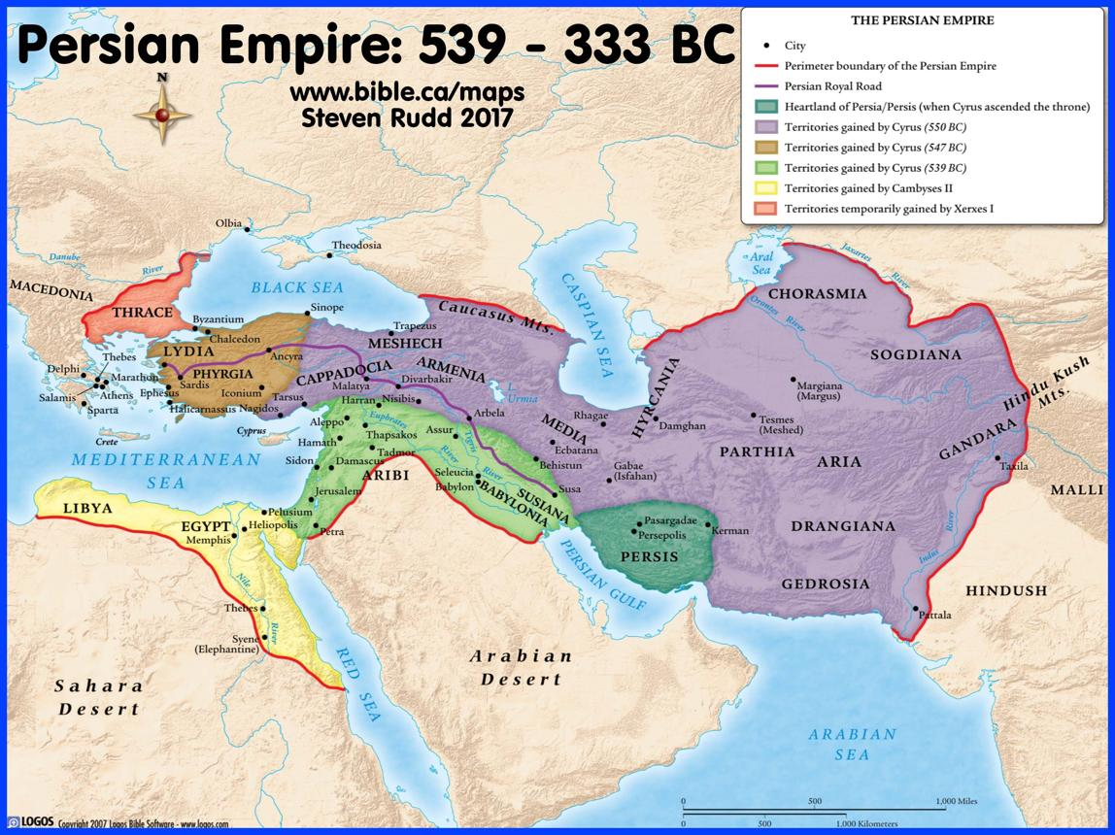

Cyrus the Great and the Persians

Daniel’s age -- 76+ y.o.
Cyrus represented a very different imperial policy toward conquered peoples.
Instead of permanently displacing populations and suppressing local religions,
Persian administration frequently permitted displaced populations to return home and restore local sanctuaries.
This policy provides historical background for Ezra 1. Cyrus authorized the Jews to return to Jerusalem and rebuild the Temple. This occurred around 538–537 BC
For the Jewish people, the Babylonian exile was beginning to end.
Yet Daniel apparently remained in the east.

Darius the Mede — Daniel 5:31 introduces "Darius the Mede."

Daniel’s age -- 76+ y.o.
Daniel 6 places Daniel under this ruler when Daniel's enemies manipulate the law and Daniel is thrown into the lions' den.
The precise historical identity of Darius the Mede remains debated.
Several proposals have been made, including that the name/title refers to a subordinate ruler or governor operating under Cyrus, or that the Danielic description reflects another arrangement in the early Persian administration.
This is one area where it is important to distinguish between what the biblical text clearly states and what historians can independently establish.
Daniel presents a transition:
Babylon → Darius the Mede → Cyrus the Persian.
Daniel 6:28 says, "So this Daniel prospered in the reign of Darius, and in the reign of Cyrus the Persian." Whatever the exact identification of Darius, the theological point is unmistakable - Daniel survives another regime change.
Kings disappear. Empires disappear. Daniel's God remains.

Daniel's approximate historical timeline
DateBC | Event | Daniel's approx. age*
620–615 | Daniel possibly born | —
612 | Nineveh falls | child
609 | Josiah killed at Megiddo | perhaps 6–11
605 | Battle of Carchemish | perhaps 15–20
605 | Daniel deported to Babylon | perhaps 15–20
605–562 | Nebuchadnezzar reigns | Young/older adult
597 | Jehoiachin/ Ezekiel deported | perhaps 23–28
586 | Jerusalem/Temple destroyed | perhaps 34–39
562 | Nebuchadnezzar dies | perhaps 58–63
556 | Nabonidus begins reign | perhaps mid-60s
539 | Belshazzar's feast/Babylon falls | perhaps 76–81
539 | Persian rule begins | elderly
538–537 | Cyrus permits Jewish return | perhaps 80+
536 | Daniel's final dated vision | perhaps 80+
*Daniel's age is estimated because Scripture never gives his birth date.

The foreign entities that shaped Daniel's life
Daniel's story becomes much easier to understand when we recognize five major peoples or political entities.

Assyria - created the political world Daniel inherited. It had destroyed northern Israel in 722 BC but collapsed during Daniel's youth.

Egypt - briefly dominated Judah after Josiah's death. Pharaoh Necho II installed Jehoiakim, the king ruling when Daniel's story begins.

Babylon / the Chaldeans - Babylon had the greatest direct impact on Daniel.
Babylon conquered Judah, deported Daniel, destroyed Jerusalem, destroyed Solomon's Temple, educated Daniel, employed Daniel, and attempted to assimilate him culturally. Yet Daniel eventually became a senior official inside the very empire that had destroyed his homeland.

The Medes - had helped destroy Assyria and later became associated with the Persian imperial system. Daniel repeatedly refers to the Medes and Persians, especially in connection with Babylon's fall.

Persia - ultimately destroyed Babylonian supremacy. Under Cyrus, Persian policy allowed Jewish exiles to return to Jerusalem. Thus the empire that conquered Daniel's captors became the instrument through which the Jewish restoration began.

Daniel's world can be summarized as a sequence of empires
There is an important pattern:
Assyria
↓ collapses
Egypt briefly controls Judah
↓ defeated at Carchemish, 605 BC
Babylon dominates Judah
↓ destroys Jerusalem, 586 BC
Medo-Persia conquers Babylon, 539 BC
↓ permits Jewish restoration
Jews begin returning to Jerusalem, 538–537 BC
Daniel personally lived through most of this transformation. That makes the visions of Daniel particularly significant.
He wasn't speculating about empires from an isolated monastery. According to the narrative, Daniel spent his adult life inside the machinery of empire.

This background explains Daniel's central theological message
The historical events explain one of the most repeated ideas in Daniel:

"The most High ruleth in the kingdom of men." — Daniel 4:17
Think about what Daniel had witnessed.
- Josiah died.
- Jehoiakim died.
- Jerusalem fell.
- The Temple burned.
- Nebuchadnezzar died.
- Nebuchadnezzar's dynasty collapsed.
- Belshazzar died.
- Babylon fell.
- Persia arose.
- Yet Daniel survived all of them.
The book therefore contrasts two realities 1)Human kingdoms are temporary and 2(God's kingdom is permanent.)
That theme reaches its fullest expression in Daniel 7.
Daniel sees successive kingdoms portrayed as beasts, but eventually:
"one like the Son of man"
approaches the Ancient of Days and receives:
dominion, glory, and a kingdom that will never be destroyed.

